NAME: K Yamini
REG NO: 192572181

Write a Prolog program for STUDENT-TEACHER-SUB-CODE.
Aim:
To write and execute a Prolog program that represents the relationship between students, teachers, and subject codes and retrieves the required information using queries.
Algorithm:
- Start the program.
- Define facts containing student names, teacher names, and subject codes.
- Create a predicate teaches(Teacher, Student, SubjectCode).
- Store the relationships in the Prolog database.
- Use queries to find the teacher of a particular student and subject.
- Prolog searches the facts and matches the given information.
- Display the matching result.
- Stop the program.
Prolog program:
% EXPERIMENT 19
% Student - Teacher - Subject Code

% Facts
teaches(ravi, yamini, 'CSA17').
teaches(priya, rahul, 'CSA07').
teaches(kumar, sneha, 'CSA12').
teaches(anitha, arun, 'CSA15').
teaches(suresh, divya, 'CSA20').

% Display student-teacher-subject details
show_details(Student) :-
teaches(Teacher, Student, SubjectCode),
write('Student: '),
write(Student),
nl,
write('Teacher: '),
write(Teacher),
nl,
write('Subject Code: '),
write(SubjectCode),
nl.
Input:
?- show_details(yamini).
Output :
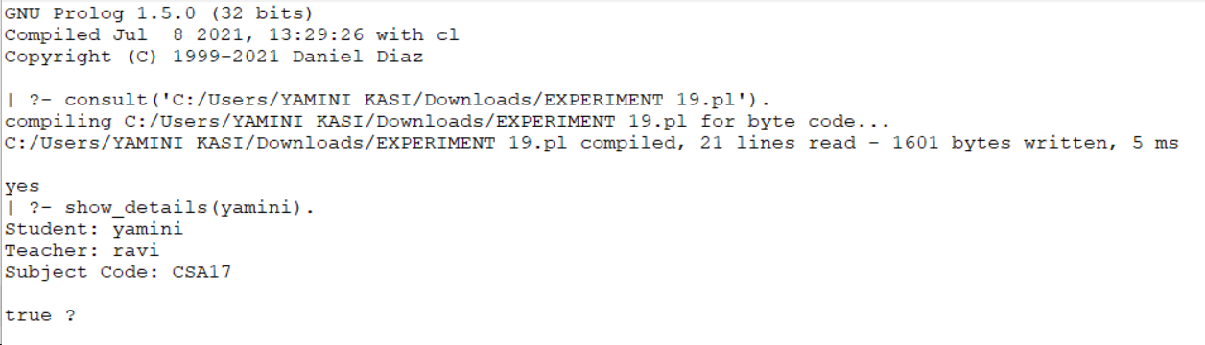

Result:
Thus, the Prolog program for representing Student-Teacher-Subject Code relationships was successfully implemented and the required information was retrieved using Prolog queries.

